[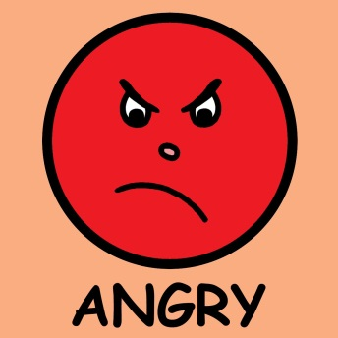](http://www.google.com/url?sa=i&rct=j&q=&esrc=s&frm=1&source=images&cd=&cad=rja&docid=F2DYDT006TEaaM&tbnid=WUJBmlvBLMBu2M:&ved=0CAUQjRw&url=http%3A%2F%2Fwww.abcteach.com%2Fdirectory%2Fclip-art-emotions-3892-2-1&ei=FdVaUf2QMamy0QHSzIDoAw&psig=AFQjCNE5D_bDaa1dyMG_uH-bUjrV0Axlpg&ust=1364993675024641)

|  |
| --- |
| **Draw a picture or write about something that makes you angry:** |
| **Draw a picture or write about how you can calm back down when you are angry:** |